Blood Bank management system

Software Engineering

Submitted by: Tanu kaushik (20211461)

Naveen(20211437)

Suraj(20211459)

Anjan(20211404)

BSc (H) Computer Science –IV -SEM , 2 Year

Submitted to: Dr.Kamlesh kumar Raghuvanshi Sir

Ramanujan College



CERTIFICATE

This is to certify that Tanu kaushik, Naveen, Suraj, Anjan the students of BSc. (H) Computer Science, Ramanujan college of Delhi University, with Roll No. 20201461,20201437, 20201459 and 20201404 respectively have made the project titled “ Blood Bank Management System” in their individual capacities under my supervision for the fulfillment of IV Semester practical examination.

(Dr. Kamlesh kr.Raghuvanshi)

ACKNOWLEDGEMENT

We extend our profound gratitude to our project guide Dr. Kamlesh kr. Raghuvanshi, for his interest, guidance and suggestions throughout the course of the project. We feel honored and privileged to work under him. He shared his vast pool of knowledge with us that helped us steer through all the difficulties with ease. This project would not have been possible without his guidance and we would like to thank him for everything he has done for us.

Tanu kaushik

Naveen

Suraj

Anjan

TABLE OF CONTENTS

|  |  |  |
| --- | --- | --- |
| Serial No. | CONTENTS | Page Number |
| 1. | Introduction |  |
| 2. | Problem statement |  |
| 3. | Project understanding docs. Purpose of project |  |
| 4. | Requirement Analysis Project feasibility |  |
| 5. | Project Planning |  |
| 6. | Risk Management |  |
| 7. | Tier ARCHITECTURE |  |
| 8. | Conclusion |  |
| 9. | References |  |
|  |  |  |

Abstract

Blood transfusion safety is a relevant and significant public health issue in the Sultanate of Oman. Since most blood banks are still in paper-based system, various disadvantages are experienced by various stakeholders, which endanger the lives of patients and deter the healthcare system. As such, the researchers aimed to design, develop, and implement an online blood bank management system (OBBMS). This web-based application allows hospitals in Oman to make inventories of their blood bags online, subsequently, allowing each hospital to check the availability of blood bags anytime. The researchers designed and administered a questionnaire that assess the perceptions of various stakeholders in both manual-based and OBBMS. Based on the findings and results, it was found out that these stakeholders perceived online blood bank management system is much better than the manual system. Therefore, with the use of online blood bank management system, blood transfusion process is safe and secured. Threats on improper blood donor documentation, or misplaced records will be totally eradicated. Also, processes involving recording about blood donors, blood bag collection, storage, and inventory will be systematized and organized, hence, improving the healthcare management for blood banks.

1.Introduction

Blood transfusion safety remains an important public health concern in Oman. The availability of blood products of all blood types and the provision of its safety ensure public trust of its excellent healthcare system. However, lack of availability of these blood products and provision of unsafe blood products still impact morbidity and mortality in the Sultanate. Through the use of online blood bank management system, blood transfusion safety is expected to be enhanced or improved. Risks on improper blood donors’ documentation, and misplaced records can be minimized or totally avoided. Also, processes involving blood bag collection, storage, and inventory will be systematized and organized, hence, improving the healthcare management.

Background of study

For hospitals, a blood bank known as blood collection center, also is an area in which collected blood bags are stored and preserved for future use in blood transfusion services. Blood transfusion is a medical operation where a patient requires blood or blood products as a life saving measure. . In an article1 published in Times of Oman in 2014, it was reported by Ministry of Health (MoH) that the total amount of blood donated annually in Muscat is approximately 25,084 units. MoH further reported that its Department of Blood Services is functioning at full capacity to meet the demands in the Sultanate. Most blood banks are still running manual system in its processes. As such, there is a lack of efficiency because it is still paper-based in collecting information about donors, inventories of blood bags, and blood transfusion services. The lack of proper documentation may endanger patients’ health due to the possibility of having contaminate blood bags. Contamination happened when there is an incomplete donors’ medical history record and the blood bags’ shelf life is not monitored properly. Hence, a web-based blood bank management system might be needed to address these issues and problems encountered to ensure blood transfusion safety.

2.Problem statement

Despite advances in technology, nowadays, most blood bank systems are running in manual system. As such, there is a prevalent problem in the availability of needed blood types. For instance, when a person needs a certain type of blood and this type is not available in the hospital, family members send messages through social media to those who can donate to them and this process takes longer than the life of the patient to the most dangerous. In addition, it seems that there is lack of proper documentation about blood donors and its medical history. This may lead to blood bag contamination and may affect the blood transfusion safety. Generally, this study aims to determine how the use of online bank management system enhance blood transfusion safety. Subsequently, this study seeks to answer the following specific problems: 1. What is the level of perception among blood bank’s stakeholders on manual-based system? 2. What is the level of perception among blood bank’s stakeholders on online blood bank management system? 3. H0: Is there no significant difference in the level of perception among stakeholders between manual-based and online-based blood bank system? H1: Is there a significant difference in the level of perception among stakeholders between manual-based and online-based blood bank system?

3.Purpose of project

This applied research aims to design, develop and implement online blood bank management system. This web-based application provides:

• To ensure hospital to have good supply or inventories of blood bags.

• To check the availability of blood bags anytime.

• To manage the information of its blood donor.

• Function to check if the person donate blood for the last 3 months.

• To allow good documentation about the donor and its blood donation activities.

• Support fast searching to find match blood bags for the right person.

Scope

This research study covers the three (3) basic operations of blood banks, namely: donor registration, monitoring of blood bags or products’ inventories, and monitoring of blood bags or products’ issuance. Also, due to time-constraint, respondents will be from hospitals from North Batinah Region in the Oman, though the research study talks about blood banks in the Sultanate of Oman. In addition, the study considers three (3) possible users of the system, namely: hospital administrator, doctors, and blood receptionists.

4. Requirement Analysis Project feasibility

4.1.1 EXTERNAL INTERFACE REQUIREMENTS

The external system is to assume full responsibility for storage functions as well as blood bank hospital management and hospital control for an entire warehouse. The interfaces in this section are specified by documenting: the name and description of each scheme, source or input, destination or output, ranges, accuracy 28 and tolerances, units of measure, timing, display formats, and organization, and data formats. The user interface required to be developed for the system should be user-friendly and attractive. The interface between the user and the system will be WIMP (Windows, Icons, Menu, Pointers) keeping in mind that the system is to be run through a web browser. All operations will be off point and click nature with all navigations performed through windows of the system specifically buttons and menu. Buttons: The button is activated when the user will click on the left click of the mouse within the bounds of the button. And thus the action associated with it will be carried out. Menu: All the operations will be arranged.

HARDWARE REQUIREMENT

Here's what you Need to Use the canteen automation system for online records:

● 20 GB HDD 256 MB RAM

● Pentium IV Processor

● Input Devices: Keyboard, Mouse

● Output Devices: Monitor, Printer

SOFTWARE REQUIREMENT

Operating System: Window XP and above Browsers: Chrome or any other latest web page supporting browser

Proposed system

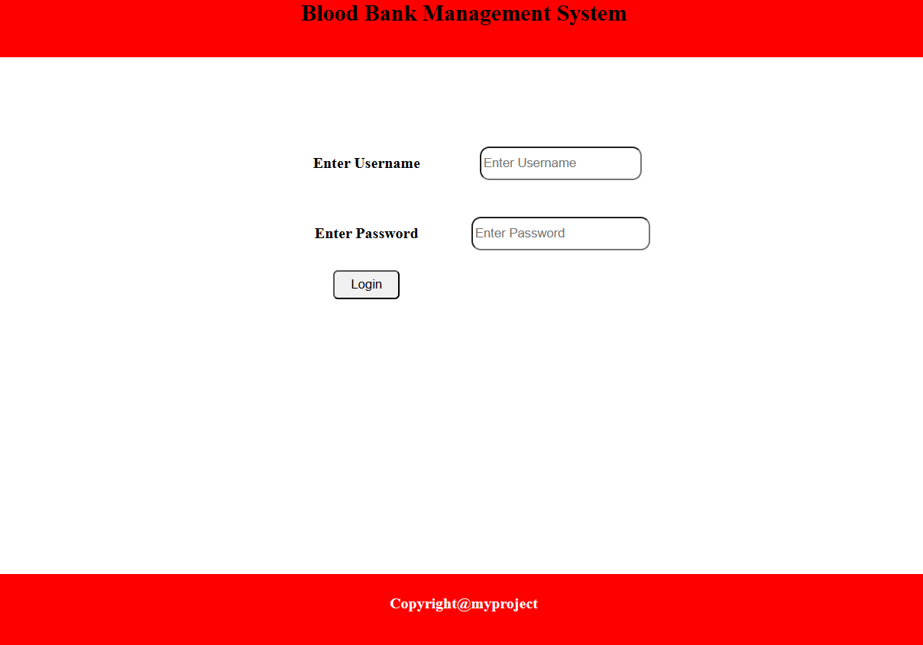

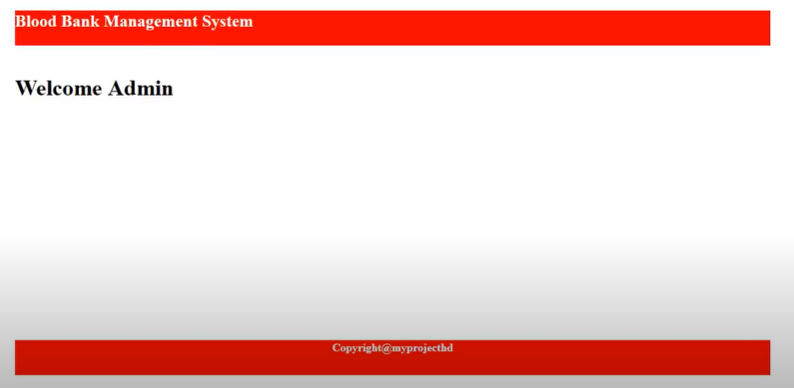

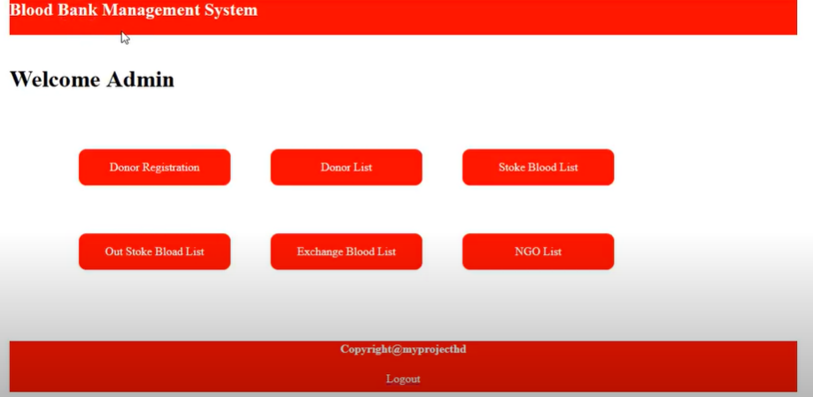

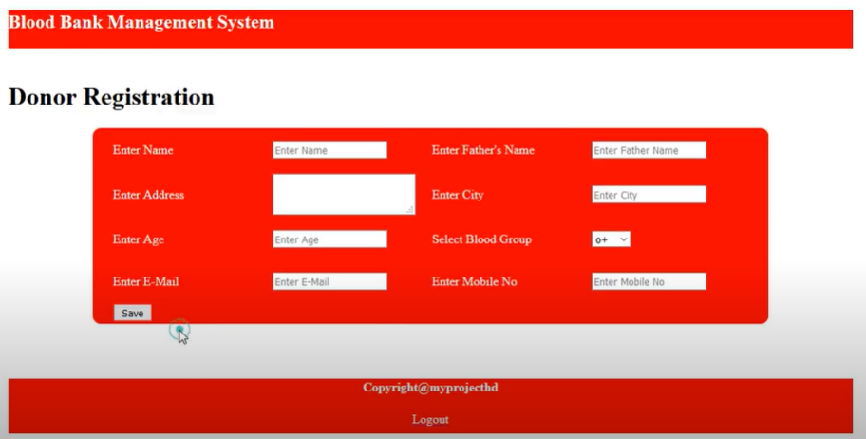

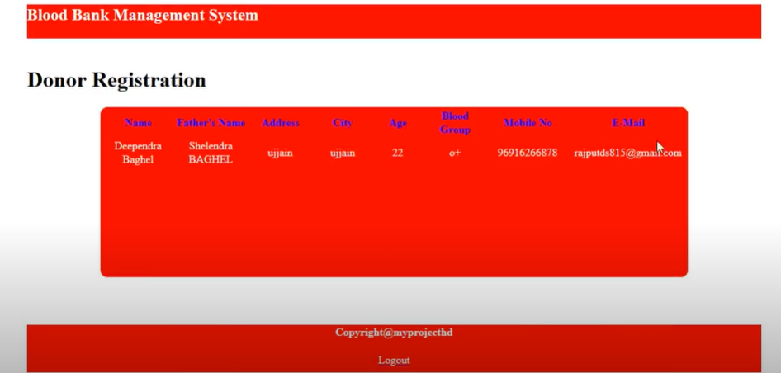

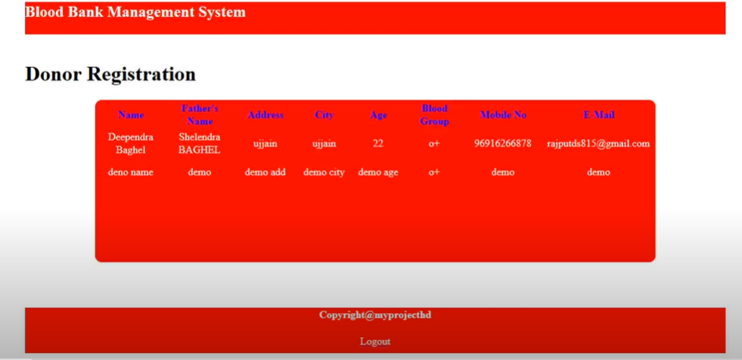

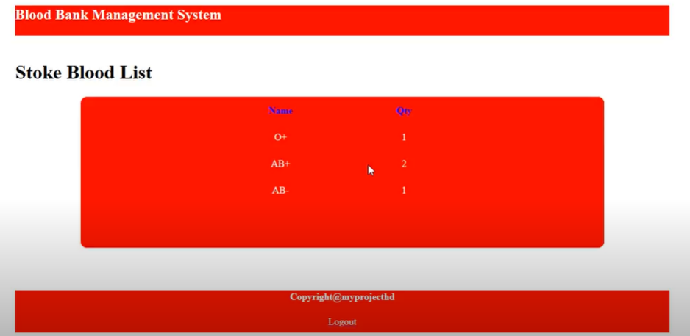

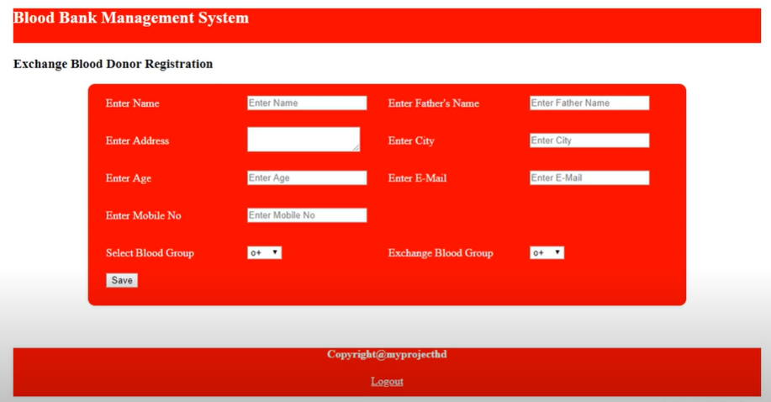

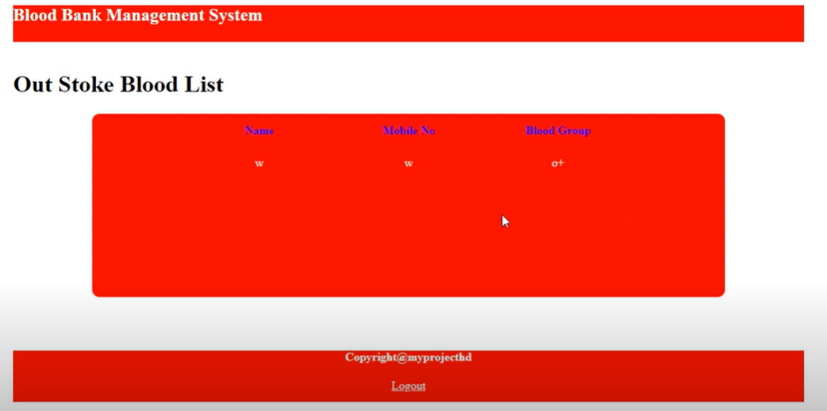

PROJECT PLANNING

Estimation

Project Metrics

Project metrics are used to control and coordinate software engineering process and to improve quality of the software to be produced. Project specific metrics provide indication of productivity and insight into the technical activities. Adapt project workflow and technical activities and code.

FUNCTION ORIENTED METRICS

Function oriented metrics use function point as normalization value. Function points are derived using an empirical relationship based on countable (direct) measure of software’s information domain and assessments of software complexity.

Calculation of complexity adjustment values:

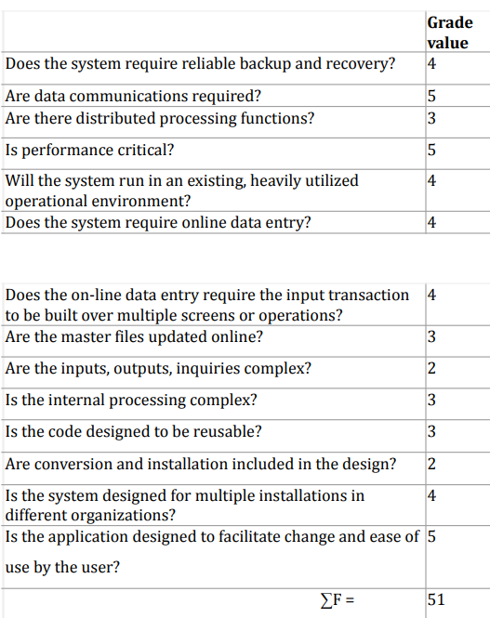Calculation of Function point for the current software:

Function point = Total count * (0.65+ 0.01 * (∑F))

= 69 * (0.65 + 0.01 * 51)

= 80.04

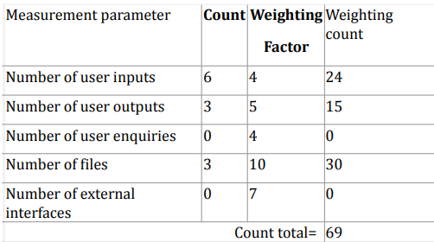

User inputs: name, address, mobile no., age, Father’s name, exchange Blood group, Mail and city

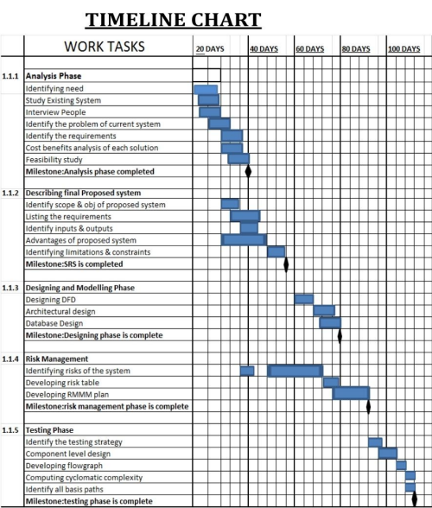 6.RISK MANAGEMENT

Identifying potential risks and developing a plan to mitigate, monitor and manage risks is of paramount importance. Risk analysis enables to build a risk table by providing detail guidelines in identification and analysis of risk. Points to be considered are:

● Risk avoidance

● Risk monitoring

● Risk management and contingency plan. For all activities that lie above the cut-off point, a mitigation plan has been developed to mitigate the risk. A plan of action is structured, and the risk is being monitored at all the phases, i.e. a number of factors are considered. In our context the risks for which a mitigation plan has been put into place are: 41

● Lack of clear product vision.

● No one may be inadequate to do the job.

● Delivery date may extend.

● Lack of documentation.

● Customers may change the requirements.

● End users may resist the system.

Impact Values for RISK TABLE

1.Catastrophic

2.Critical

3.Marginal

4.Negligible

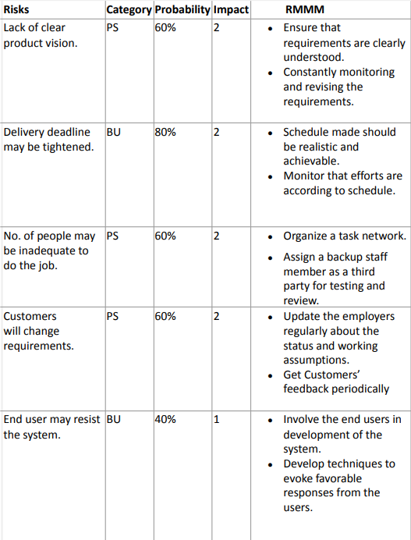For our project the RISK TABLE is above

7.TIER ARCHITECTURE

The various classes as obtained from the business class diagram is categorized as follows:- The 3 tier architecture consists of three layers: Presentation Layer:- The website or windows forms application is called the presentation layer. The presentation layer is the most important layer simply because it's the one that everyone sees and uses. Even with a well-structured business and data layer, if the presentation layer is designed poorly, this gives the users a poor view of the system. The presentation layer is the form where we design using the controls like textbox, labels, command buttons etc.

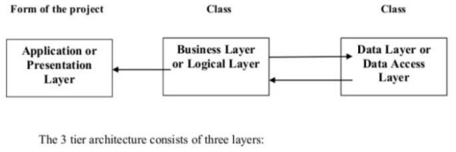

Business Layer: - Though a website could talk to the data access layer directly, it usually goes through another layer called the business layer. This layer is a class which we use to write the function which works as a mediator to transfer the data from Application or presentation layer data layer. In the three-tier architecture, we never let the data access layer interact with the presentation layer. This layer is also a class where we declare the variable corresponding to the fields of the database which can be required for the application and make the properties so that we can get or set the data using these properties into the variables. These properties are public so that we can access its values. One of the best reasons for reusing logic is that applications that start off small usually grow in functionality. For instance, a company begins to develop a website, and as they realize their business needs, they later decide to add a smart client

application and windows service to supplement the website. The business layer helps move logic to a central layer for "maximum reusability" Business layer have been presented having two roles • client application • server component.

An example of Business Layer-The Business layer has functions which take the parameters from the example given in the presentation layer As the user inputs the data values. corresponding functions are called in the business layer which is further passed on through the data layer where corresponding procedures are called and the data is updated. The business layer is the class where we write the functions which get the data from the application layer and pass through the data access layer.

Data layer :- The key component to most applications is the data. The data has to be served to the presentation layer somehow. The data layer is a separate component whose sole purpose is to serve up the data from the database and return it to the caller. This layer is also a class which we use to get or set the data to the database back and forth. This layer only interacts with the database. We write the database queries or use stored procedures to access the data from the database or to perform any operation to the database.

ADVANTAGE OF 3 TIER ARCHITECTURE

●Client-Server architecture is 2-Tier architecture because the client does not distinguish between the Presentation layer and the business layer.

●The increasing demands on GUI controls caused difficulty to manage the mixture of source code from GUI and Business Logic.

● Further, Client Server Architecture does not support Change Management. Let suppose that the 47 government increases the Entertainment tax rate from 4% to 8%, then in the Client-Server case, we have to send an update to each client and they must update synchronously on a specific time otherwise, we may store invalid or wrong information.

●The Client-Server Architecture is also a burden to network traffic and resources. Let us assume that about five hundred clients are working on a data server then we will have five hundred ODBC connections and several ruffian record sets, which must be transported from the server to the clients.

* This categorization of the application makes the function more reusable easily and it becomes too easy to find the functions which have been written previously. If the programmer wants to make a further update in the application then he can easily understand the previously written code and can update easily.

DISADVANTAGES

● Increase complexity effort

●More difficult to build 3 tier architecture rather than a 2 tier.

●Points of communication are doubled. Maintenance tools are currently inadequate for maintaining server libraries.

Why Incremental RAD model?

1. Incremental models are advisable where requirements are clear and the development time is less. The striking feature of the incremental model is that each module can be completed and released as and when the requirement arises because of lack of time.

2. As in our system, many of the modules are not interrelated so can be released in isolation. The user can thus get a feel of these modules and give his feedback which can be utilized for making the software more user-friendly and in line with the user requirements.

Conclusion

The blood management system has been experimentally proven to work satisfactorily by

developing web applications and the system can be by donor and user etc

We learned many skills such as database modelling, other web tools that we use for this

project and being able to work together as a team during this project .

The demo patient,donor and manager tested successfully on our system to find a donor, blood

bank and request them to donate blood. Thus a blood management system is successfully

developed ,implemented and tested.

6.2 Future Scope:

a. In future we will update our system continuously

b. We will develop live chat feature

c. Track location of the donor etc.

REFERENCE:

(1.)WHO Blood safety and availability, (n.d). <https://www.who.int/news-room/fact>

-sheets/detail/blood-safety-and-availability

(2.) Software Engineering, A Practitioner’s Approach Eigth Edition by Roger S. Pressman

(3.) Aggarwal, K. K., & Singh, Y. (2007). Software Engineering. 3rd edition.

(4.)www.wikipedia.com